# Sardauscan Tutorial

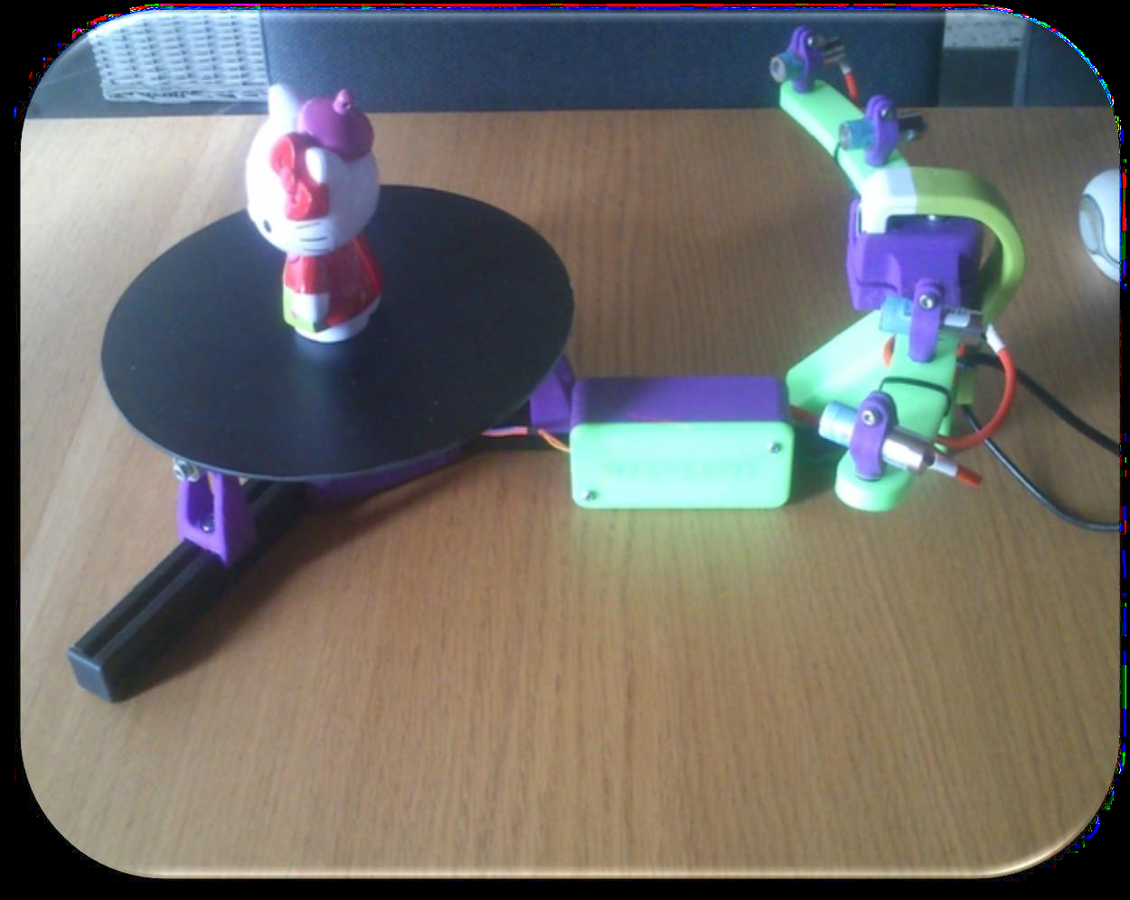

This user manual only deals with the steps to calibrate and

Scanning an object in 3D with the scanner Sardauscan, the design part of the scanner

Will not be discussed in this tutorial. If you want to build your Sardauscan

Please visit: [http://www.thingiverse.com/thing:702470](https://translate.google.com/translate?hl=en&prev=_t&sl=fr&tl=en&u=http://www.thingiverse.com/thing:702470) where everything is

(Equipment to be purchased, program for the Arduino, design of printed parts).

Sardauscan is a low-cost, open-source 3D scanner that can compete

With a very good "plug and play" scanner costing more and being closed to any

Change.

The Sardauscan uses red light beams, which will be Detected by the webcam, the webcam records the deformation of the light beam And then translate it as an image on the software.

Provide a large space around the scanner to prevent the scanning from recording

Shapes too close, causing noise and false scan.

**Summary**

• Installing the software interface 3-8 __________________________

• Hardware Calibration 9-17 ________________________________

• Camera Calibration 10 ___________________________________

• Calibration laser_____________________________________11

• Calibration position___________________________________12

• Image Calibration laser________________________________13

• Calibration matrix __________________________________ 14-16

• Scan and treatment _____________________________________ 17-18

• Some scans _______________________________________ 19-23

**Installing the Interface Software**

Go [https://github.com/Sardau/Sardauscan](https://translate.google.com/translate?hl=en&prev=_t&sl=fr&tl=en&u=https://github.com/Sardau/Sardauscan) to download

Interface software.

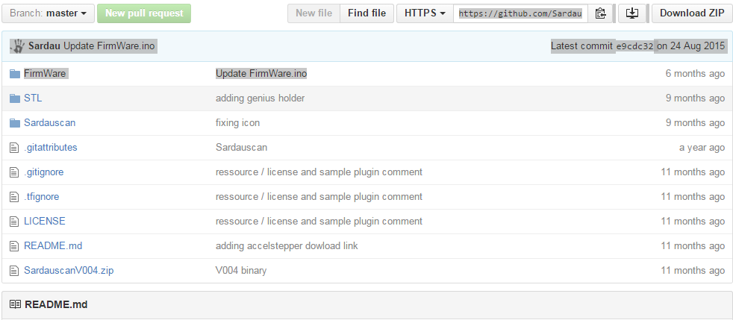

Download the ZIP file, Once the zip folder is downloaded, move the file

Zip in your documents (it will automatically unzip). But we still have to deziper

Another file in Sardauscan-master

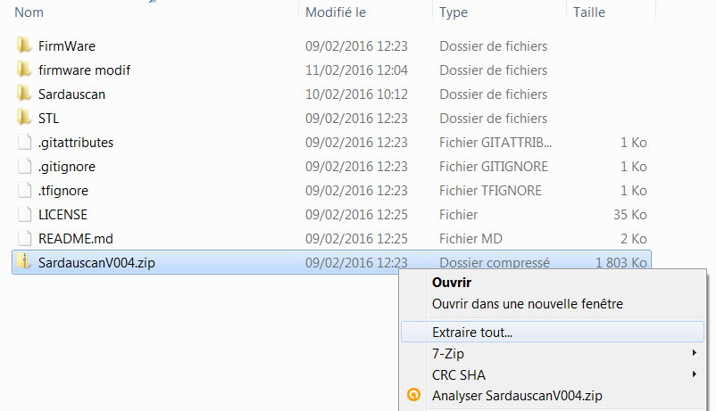

Once you have extracted the file, you have another file on behalf of

"SardauscanV004" that appeared, enter this folder and then run the executable.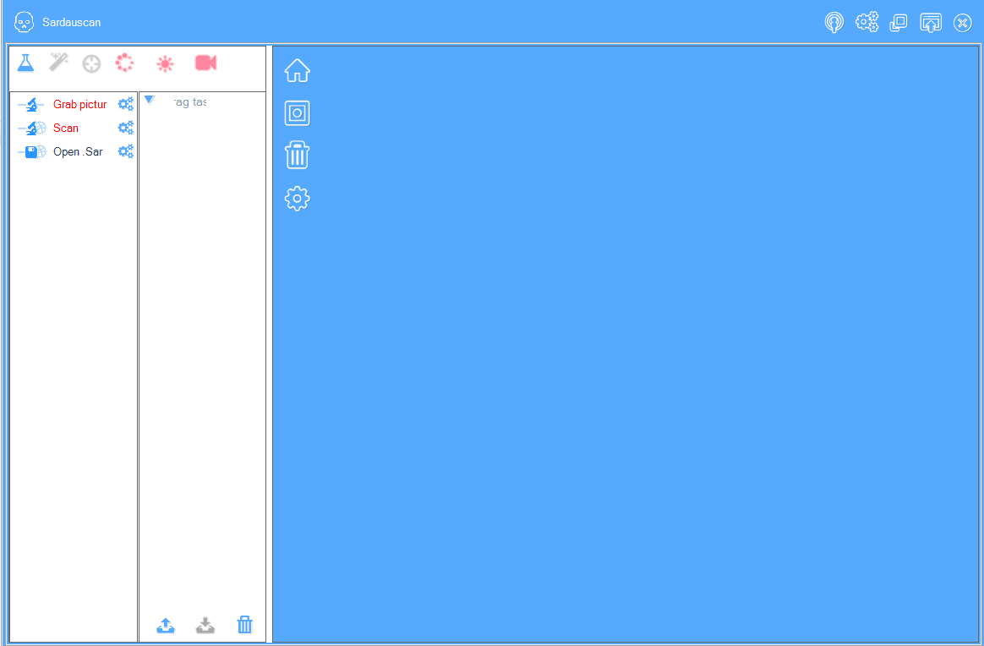

So you have your software launched, you have to recognize the different elementsOf the scanner, previously connected



Click on the tray or lasers icon, a window will openUpdate, select the proposed USB port and click “ok”.

If nothing is detected, do not hesitate to unplug / reconnect the Arduino card

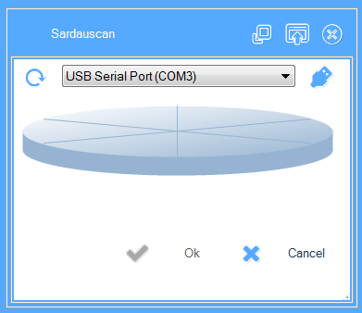

For the camera to check even if the icon is blue indeed the software may have recognized the camera

Integrated if you are using a laptop. To remove the built-in camera right click

On the icon then "remove"

Then choose “Hercules HD Twist” then click on “ok”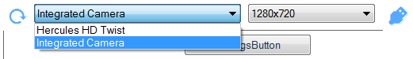You can normally use each laser and the

Clicking on the laser icon, and then activating each laser independently.

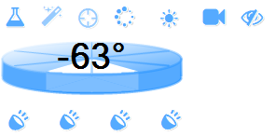

It is likely that the tray does not turn, check whether LEDs on the board

Are on, if they are lit the tray is working, if not

Not the case, it is necessary to modify some parameters in the Arduino code

In case of problem

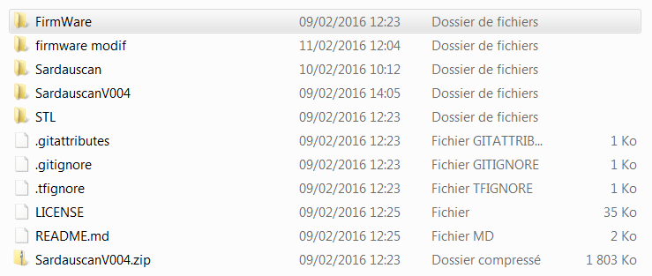

Open the FirmWare folder

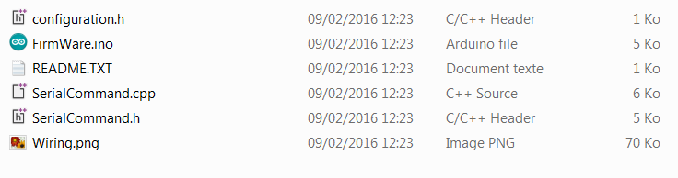

Then open Firmware.ino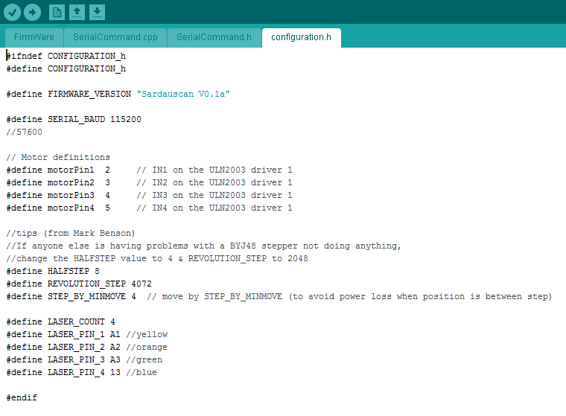

In case of problem Open the FirmWare folder

Then open Firmware.ino

All you have to do is change "#define Halfstep 8 #define REVOLUTION_STEP

4072 "

By "#define Halfstep 4 #define REVOLUTION_STEP 2048 "

Then click on "upload" the New program is in the Arduino map

An error message may appear, because it may be missing a library in yourArduino software. For this go on <https://github.com/adafruit/AccelStepper> and Download the file, and rename the “AccelStepper”Lowercase / uppercase.

Back in Arduino software

Add the AccelStepper library, then upload the new program, the latter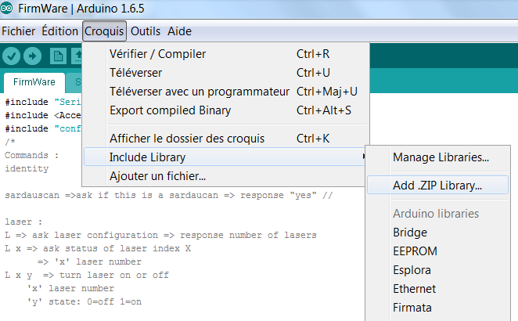Should then settle into your Arduino without worries.

Your interface is now ready for use, but now you have to calibrate theto scan.

Hardware calibration

We will now calibrate the scanner, this task is the longest and the most

Complicated, but it is necessary that the calibration be done with care to obtain a result

Of good quality, so be patient and accurate.

To calibrate I advise you to print in 3D a half-cone (cut in height)And make a groove in its height (in the direction of the lasers), make the color black, this Which avoids the diffusion of light through the material, which can distort our accuracy.

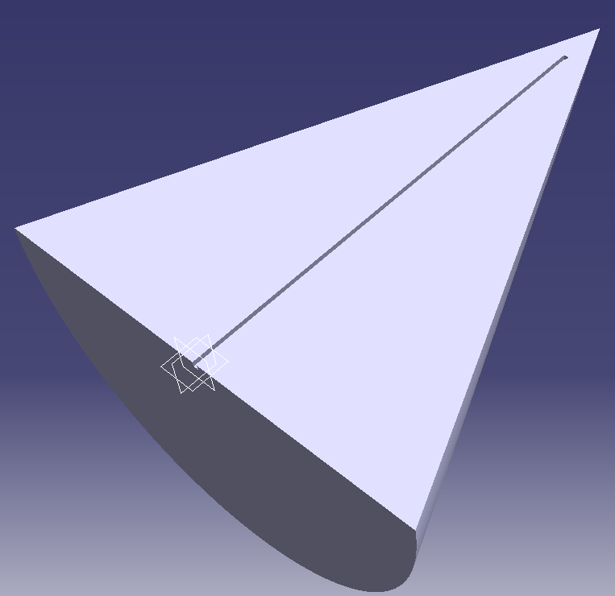

You have previously found the center of your turntable if it is notYou have to try to determine it, you can help yourself with your half-cone and Your lasers. Place your half-cone on the board and pass a laser through its top,Then rotate the tray, if the laser still remains at its top, you have found the Center of the tray (mark its center for the next uses of the scanner)

Calibration camera

To calibrate the camera nothing more simple, go to the camera tab, then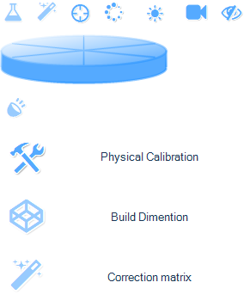In the “Physical calibration” section Simply click on the barHorizontal and place it on the Center of your tray, so yourCamera will be calibrated for scans Further.

Calibration lasers

Laser calibration is one of the most complicated tasks to performBy its precision. You will need to perform the operation for **each laser independently.** You need your half cone that you will place in theCenter of the tray, the flat side of the camera side.

Adjust the light beam so that it is as thin as possible by turning the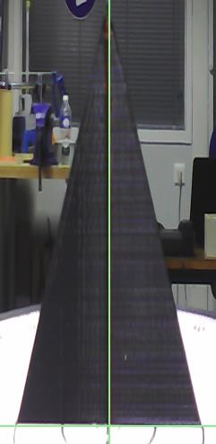Knob directly onto the laser. Then direct the light beam into the groove of the Half-cone (the groove is in the center of the tray). On your image you have toThe screen you do not have to distinguish the laser behind the green bar (see below).

Calibration Position

If you have not already done so, you have to calibrate the dimensions of your scanner, that is to say

Positions of your camera and your different lasers, for that go in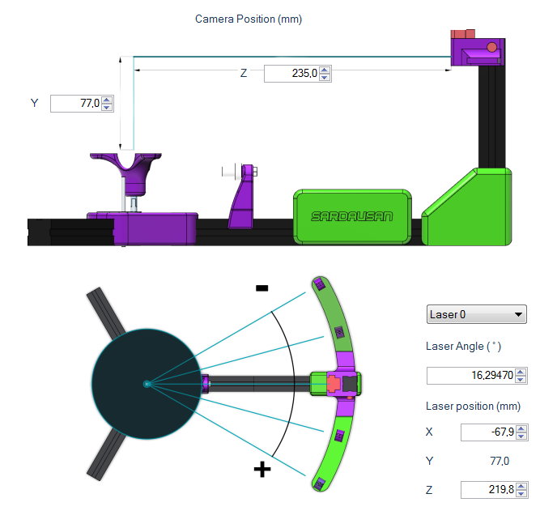Tab “calibrate”, then in “build calibrate” and enter the coordinates of the camera **Tip:** Do not switch the angle of the laser in accordance with the sign, contact informationWill adjust themselves. Check all laser angles that can move by adjusting The other lasers.

**Tip:** print a circular protractor that you'll stick on the shelf

Calibration of the laser image

We will now adjust the image of the laser, ie eliminate possible noiseThat the camera records. To do this go to the “tune” icon and set for the parameters So as to have a continuous line, and eliminate all isolated points.

The setting is different for each piece of scanned material (material reflection,**color), it is essential to do so with THE piece you want to scan.**

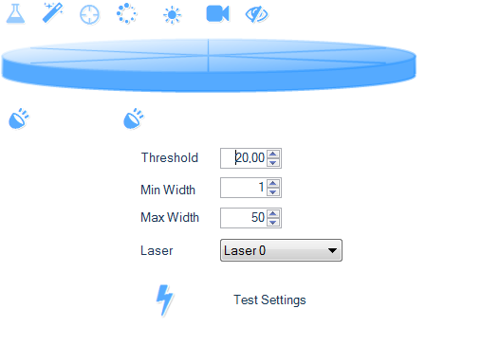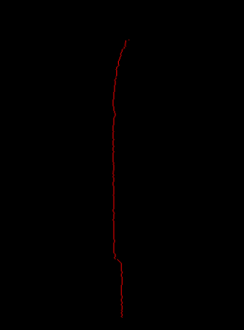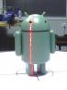

Correction of matrix

Matrix Correction is the last calibration step of the scanner and the mostImportant. To do this take a piece with a particular shape, a tube with a bar Crossing it in its radius see next photo

Your calibration object must have a simple but irregular shape (eg noSingle tube).

Now go to the tab “calibrate” then in “correction matrix

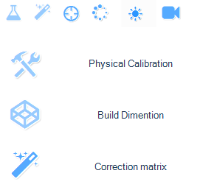

Place your calibration object in the center of the tray, and then start a quick scan. YouWill get shapes in your window (top view) so you just have to align Your scans of different colors to make one.

**Tip:** Go see the “Process” tab and look what color scan respectsScale the scanned object, do not touch the scan respecting the scale and align the others. Yes The scans are not to scale but are aligned, a processing function allowsTo correct this error

Here the green respects the dimensions, so we must align the red scanner on the green,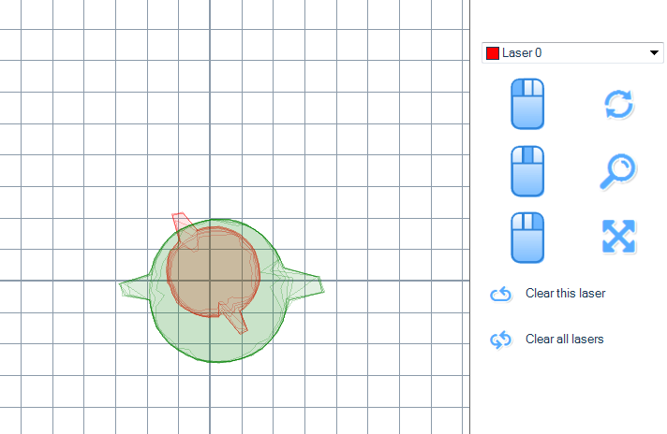

Before any manipulation click on “clear this scan” and do it for each scan

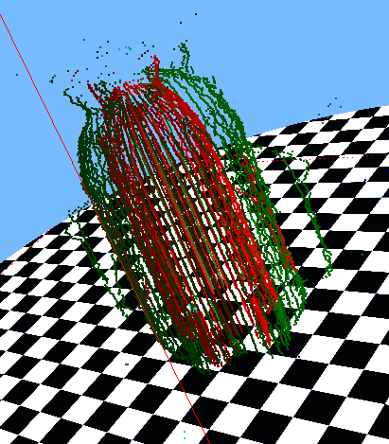

Note in “process” that the scanRed is more “lean” than the green scan, And the green scan is on a good scale, itMust therefore align with the green scan.

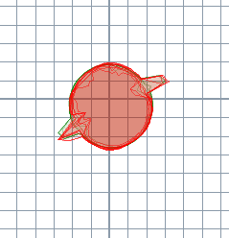

Your scan is now calibrated, we will be able to scanTreatment to eliminate noise and smooth scans

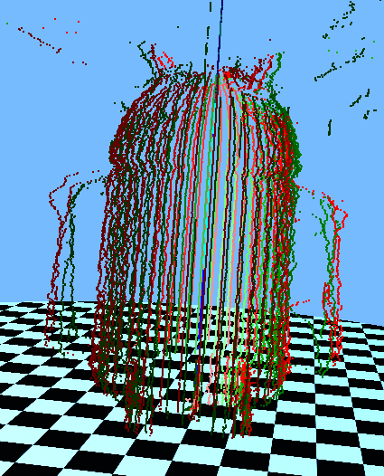

Scanning and processing

Since the calibration of the scanner is done we can now do our first scans.

Go to the “process” tab and then drag the scan icon in the “drag task here” window

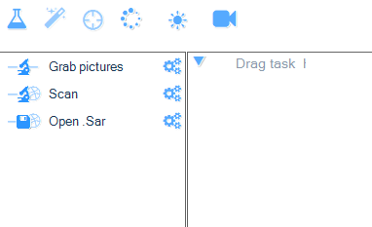

A treatment list will then appear on the left side of your window, whereEach icon has a specific function

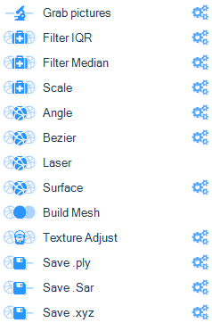

Represents the filter icon andtransformation Represents the dot smoothing iconRepresents the icon of Represents the color iconRepresents the backup icon Represents the parameter iconThe detail of each function is described in the following

Filter:

Filter IQR: Removes scan errors with an IQR filter (standard filter in samplesOf probabilities).

Filter Median: Removes scan errors with a “Median filter” (standard filter inThe imagery).

Transformation:

Scale: Changes the scale to (x, y, z).

Smoothing:

Angle: Makes an average approximation of all scanlines based on an angle.

Laser: Makes an average approximation of all scanlines based on an angle.

Bézier: Makes an approximation of Bézier on each of the scanlines.

Surface: Makes surface smoothing with a simplified Laplace.

Color:

Texture Adjust: Adjusts the brightness, contrast and gamma of the texture.

Backup:

Load Sar: Opens a “.sar” file.

Save xxx: Save a xxx file. (Xxx, is for ply, xyz, ect).

The .ply and .xyz files are there if you prefer to use aSurface reconstruction as “Meshlab” or other.

The .stl and .obj files are there for slicers (.obj files can be importedIn 3D modelers like “3ds Max” or “Blender”.

**Tip:** It is advisable to make the raw scan and save it for later onlyWork on scatter cloud processing. You must therefore drag the scan icon The icon “IO: save.sar” in the right window.

Then import your .sar file into the software to apply the processing

Some scans

Here are some examples of scans with different objects and treatmentsI use only two lasers for the moment, which are placed in position 1 and 2, are the positions closest to the camera.

Scans are very sensitive to the external environment and therefore to the parameters that

We must apply to have a correct rendering. So I advise you to be in a roomNot too bright and not to put the scan in direct light and under a lamp, indeed Too much luminosity decreases the precision of the laser and the outside light can vary and thereforeChange the quality of the scan.

Objects that fit on “legs” or “legs” are not ideal for scanningSince the ground will then be scanned and may be misinterpreted when processing the objects.

Shiny objects are also not recommended because the material diffuses the laser andCamera does not capture deformation

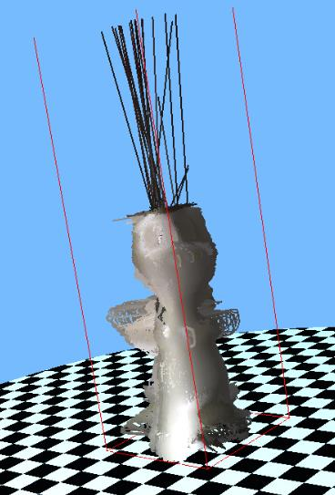

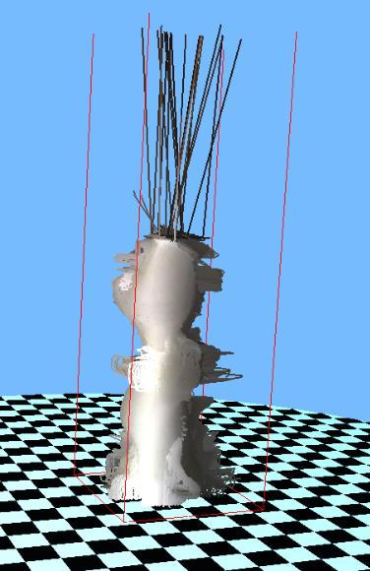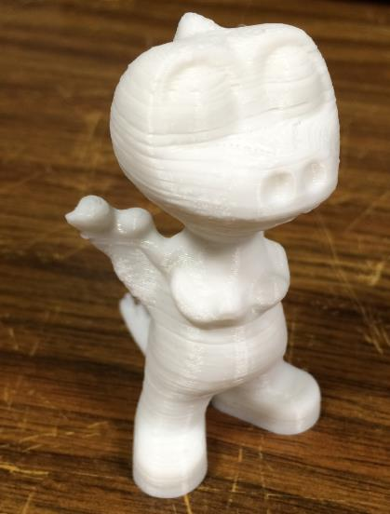

Here it is noted that the dragonnet which is itself printed as a printer material3D lack of details at the back, hands and tail is missing. We notice Pikes above his skull because the scan did not take the points of the skull (noVisible) and connected directly with spurious points.

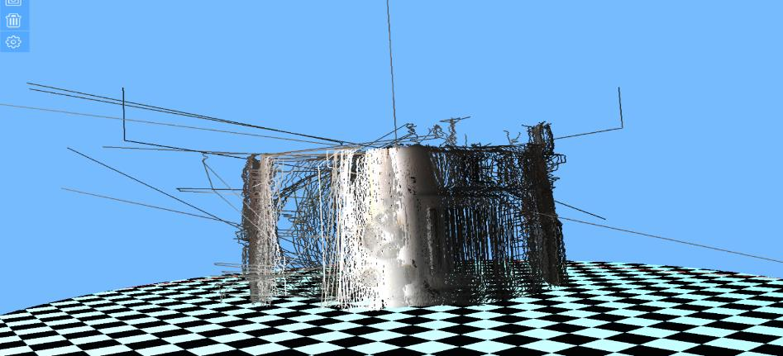

For the camera on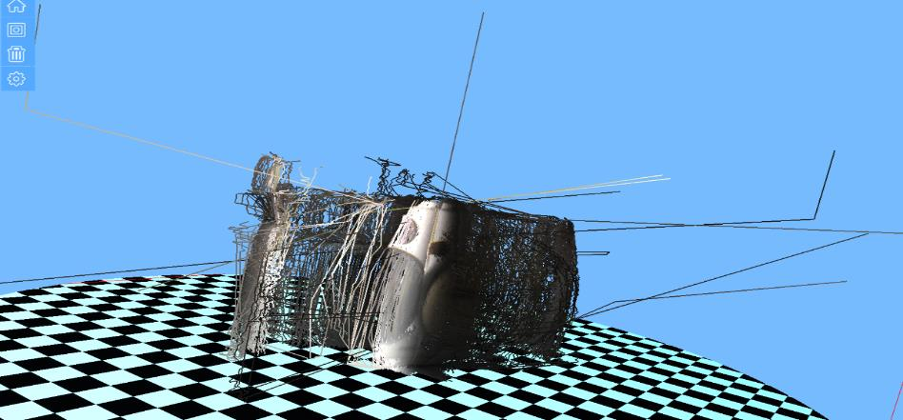Notes that it lacks Of detail, this is due to theOf the object, in fact when the Turns the lasersChange or little position On the face of the object. And so weDoes not take into account The object.

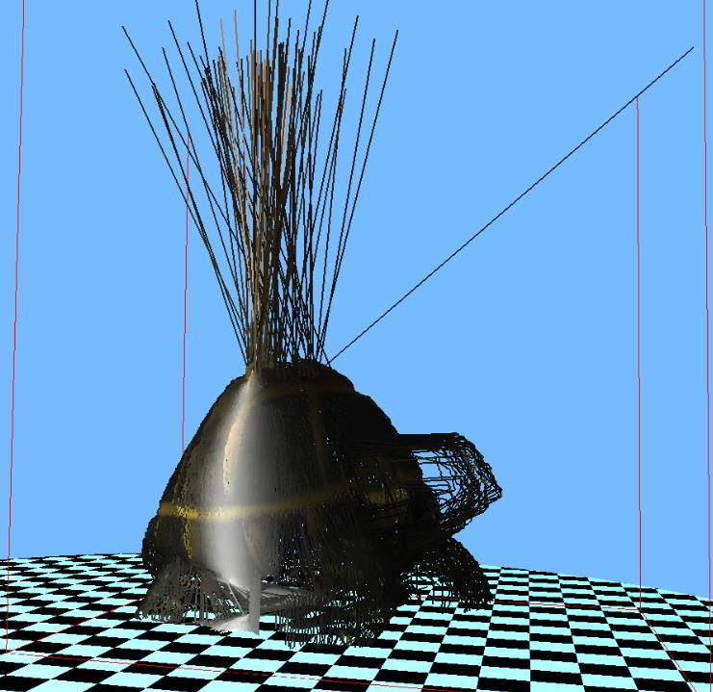

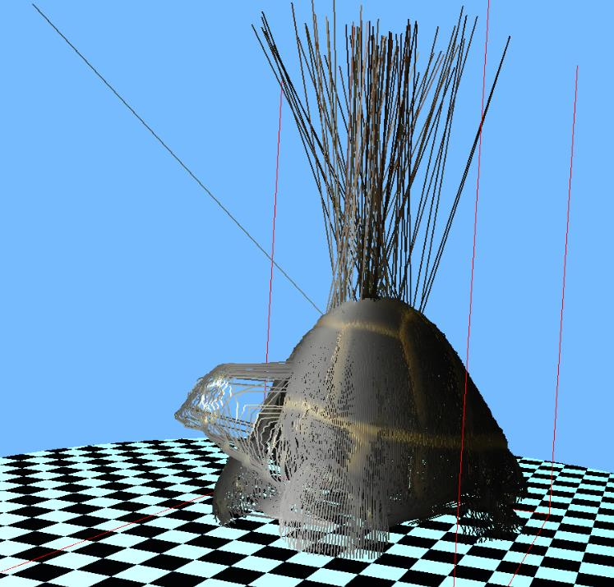

The tortoise is found in the case of the dragon with the top which is not scanned andWhose treatment links the points of the carapace with parasites. For the head one finds himself In a particular case where lasers are too inconsistent with the camera and thereforeScan not the shape of the head

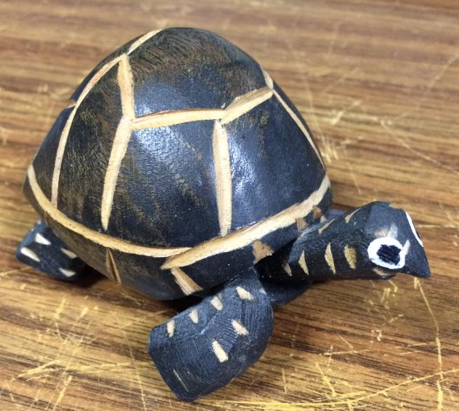

Balloon inflator is a rich object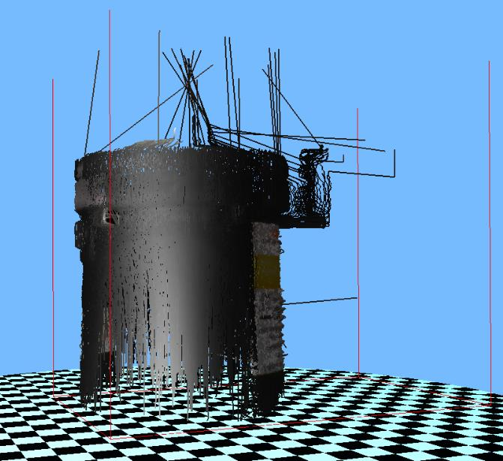In details especially at the level of the grid Thermal evacuation of the object, which did notCould be scanned correctly, due to the Large size of the object, the top of the objectIs not scanned

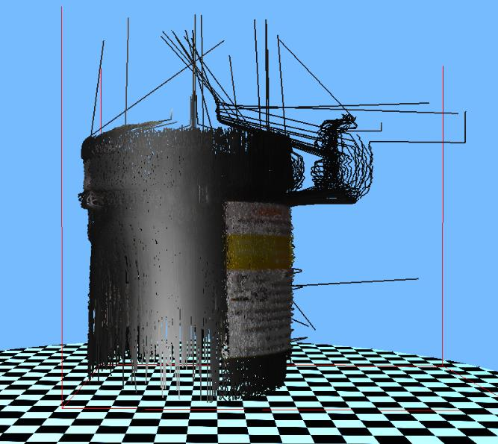

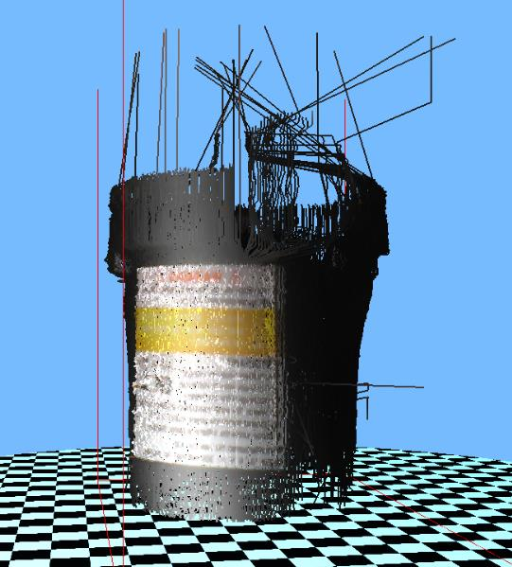

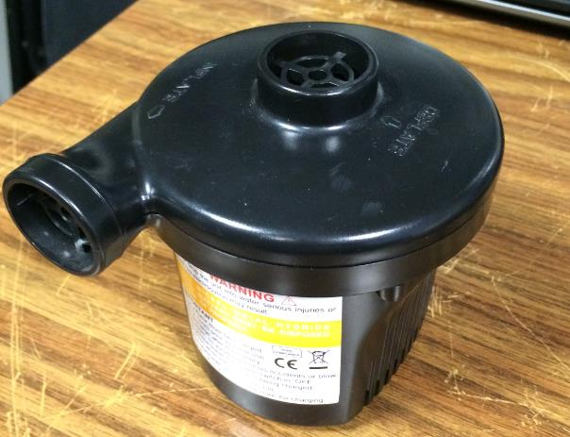

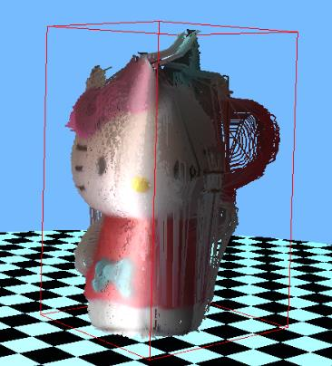

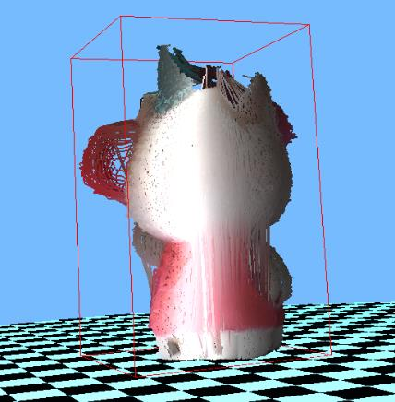

The Hello kitty remains an ideal object for this scanner one notices that the details are of

Good quality, however here a sudden drop in brightness (a cloudThe sun) modified some points of the scan (white lines on the side of the balloon) and thus Rendering the scanner rendered.

